Week 2 Assigment

laknath Gunathilake

January 15, 2020

source("http://www.openintro.org/stat/data/cdc.R")

## NOW ON YOUR OWN

### 1. Make a scatterplot of weight versus desired weight. Describe the relationship between these two variables.

plot( cdc$weight , cdc$wtdesire )

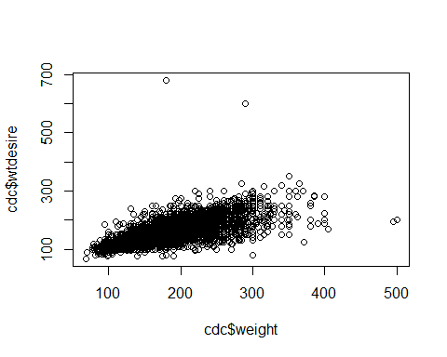

The actual weight and desired weight seem to have a strong association between 75 and 275lb. However, this relationship is weaker for those who are above 300lb.This would make sense since, we can assume that those who are overweight/obese hope to loose weight, and thus have a desired weight that is lower than their current weight.

### 2. Let’s consider a new variable: the difference between desired weight (wtdesire) and current weight (weight).

Create this new variable by subtracting the two columns in the data frame and assigning them to a new object called wdiff.

wdiff = cdc$wtdesire - cdc$weight

### 3. What type of data is wdiff? If an observation wdiff is 0, what does this mean about the person’s weight and desired weight What if wdiff is positive or negative?

class(wdiff)

## [1] "integer"

* The class of Data is an Integer
* the actual weight and the desired weight are the same:or a person weighs exactly how much they want to weigh.
* negative wdiff=This means that the actual weight is higher than desired weight (They would hope to loose weight)
* positive wdiff=This means that the the actual weight is lower than the desired weight (they would hope to gain weight)

### 4. Describe the distribution of wdiff in terms of its center, shape, and spread, including any plots you use.

hist(wdiff,breaks = 75,xlim = c(-250,200),ylim = c(0,9000))

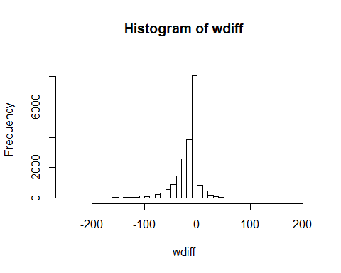

mean(wdiff)

## [1] -14.5891

median(wdiff)

## [1] -10

min(wdiff)

## [1] -300

max(wdiff)

## [1] 500

library(moments)  
 skewness(wdiff)

## [1] -1.447632

* the wdiff slightly left skewed
* wdiff has mean desired weight of -14.5 and a median desired weight of -10. Based on this we can conclude that most people are unhappy about their weight (They hope to have a weight lower than their current weight)

### 5.Using mumerical summaries and a side-by-side box plot, determine if men tend to view their weight differently than women.

boxplot(cdc$wtdesire~cdc$gender,col=(c("blue","pink")))

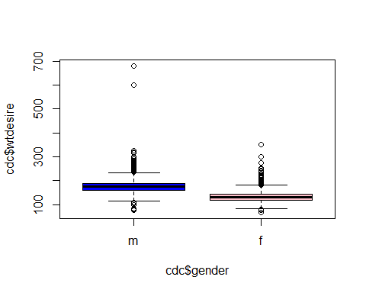

tapply(cdc$wtdesire,cdc$gender, mean, na.rm=TRUE)

## m f   
## 178.6166 133.5150

tapply(cdc$wtdesire,cdc$gender, median, na.rm=TRUE)

## m f   
## 175 130

* It is evident that men tend to have a higher desired weight on average than women. On average, men seem to be want to be around 178lb while women hope to be around the 133lb mark.

### 6.Now it’s time to get creative. Find the mean and standard deviation of weight and determine what proportion of the weights are within one standard deviation of the mean.

mean(cdc$weight)

## [1] 169.683

sd(cdc$weight)

## [1] 40.08097

within_one_negative<-mean(cdc$weight)-sd(cdc$weight)  
within_one_positive<-mean(cdc$weight)+sd(cdc$weight)  
  
within_one_sd<-cdc$weight[ cdc$weight >= within_one_negative & cdc$weight <= within_one_positive]  
length(within_one_sd)/length(cdc$weight)*100

## [1] 70.76

* 70 percents of the weights are within one standard deviation of the mean weight which is169.68295